|  |
| --- |
| detail of persons hands with scissors, markers, workingCAPSTONE: Hepatitis C Virus (HCV) for Egyptian patients Data Set |
|  |

|  |  |  |
| --- | --- | --- |
| CAPSTONE |  |  |
| Prepared by **Lucia Oviedo**  August 12, 2020 |  |  |

Table of Contents

Overview 3

Getting to know our data 3

Prepare and Explore the data 4

Data Types 4

Correlation 6

Covariance Estimation 7

EDA 8

BHStaging 8

ALT1 8

RNA12 8

ALTafter24w 9

RNAEF 9

RNABase 9

Symptoms 9

WBC 10

Age and Gender 10

AST1 VS ALT1/ BHStaging 11

RNA12 VS RNAEF/ BHStaging 11

Feature Engineering and Dimensionality Reduction 12

One-Hot Encoding 13

Classification 14

Model Evaluation decision rules 1

Model Evaluation for clasification 2

# Overview

Problem: Liver biopsies are typically the standard diagnosis of liver progression. However, it is associated with serios complications, inconvenient to patients and expensive. The goal is to generate a reliable model implementing machine learning algorithms to substitute liver biopsy and determine the degree of liver fibrosis.

## Getting to know our data

Egyptian patients who underwent treatment dosages for HCV about 18 months. Discretization should be applied based on expert recommendations as follows.

|  |  |  |
| --- | --- | --- |
| Feature Names | Feature Values | Discretization (Items) |
| Age | 32:61 | [0; 32], ]32; 37], ]37; 42],]42; 47], ]47; 52], ]52; 57],]57; 62] |
| Gender | Male,Female | [Male], [Female] |
| BMI(Body Mass Index) | 22:35 | [0; 18:5[ [18:5; 25[, [25; 30[, [30; 35[, [35; 40[ |
| Fever | Absent, Present | [Absent], [Present] - |
| Nausea/Vomiting | Absent, Present | [Absent], [Present] - |
| Headache | Absent, Present | [Absent], [Present] - |
| Diarrhea | Absent, Present | [Absent], [Present] - |
| Fatigue | Absent, Present | [Absent], [Present] - |
| Bone ache | Absent, Present | [Absent], [Present] - |
| Jaundice | Absent, Present | [Absent], [Present] - |
| Epigastria pain | Absent, Present | [Absent], [Present] - |
| WBC(White Blood Cells) | 2991:12101 | [0; 4000[, [4000; 11000[, [11000; 12101] |
| RBC(Red Blood Cells) | 3816422:5018451 | [0; 3000000[, [3000000; 5000000[,[5000000; 5018451] |
| HGB(Hemoglobin) | 2:20 | If (Gender==[Male]):[2; 14[, [14; 17:5], ]17:5; 20]If(Gender==[Female]):[2; 12:3[, [12:3; 15:3], ]15:3; 20] |
| Plat(Platelet) | 93013:226464 | [93013; 100000[, [100000; 255000[,[255000; 226465[ |
| AST1(1 week) | 0.088888889 | [0; 20[, [20; 40], ]40; 128] |
| ALT1(1 week) | 0.088888889 | [0; 20[, [20; 40], ]40; 128] |
| ALT4(4 weeks) | 0.088888889 | [0; 20[, [20; 40], ]40; 128] |
| ALT12(12 weeks) | 0.088888889 | [0; 20[, [20; 40], ]40; 128] |
| ALT24(24 weeks) | 0.088888889 | [0; 20[, [20; 40], ]40; 128] |
| ALT36(36 weeks) | 0.088888889 | [0; 20[, [20; 40], ]40; 128] |
| ALT48(48 weeks) | 0.088888889 | [0; 20[, [20; 40], ]40; 128] |
| RNA Base | 0:1201086 | [0; 5], ]5; 1201086] |
| RNA 4 | 0:1201715 | [0; 5], ]5; 1201715] |
| RNA 12 | 0:3731527 | [0; 5], ]5; 3731527] |
| RNA EOT | 0:808450 | [0; 5], ]5; 808450] |
| RNA EF(Elongation Factor) | 0:808450 | [0; 5], ]5; 808450] |
| Baseline Histological Grading | 1:16 | [1]; [2]; [3]; :::[16] |
| Baseline Histological Staging | F0:F4 | [No Fibrosis], [Portal Fibrosis],Staging (Class Label) [Few Septa], [Many Septa], [Cirrhosis] |

We have 29 columns with 1385 observations.

* General Info: Age, Gender, BMI
* Symptoms: Fever, Nausea/Vomiting, Headache, Diarrhea, Fatige, Bone ache, Jaudice, Epigastria pain
* Labs: WBC, RBC, HGB, plat, AST1, ALT1, ALT4, ALT12, ALT24, ALT36, ALT48, RNA Base, RNA 4, RNA EOT, RNA EF
* Baseline: Historical Grading and Historical Staging

# Prepare and Explore the data

### Data Types

Nominal values: Fender, Fever, Nausea & Vomiting, Headache, Diarrhea, Fatigue and Bone Ache, Jaundice, Epigastric pain, Baseline Historical Grading, Baseline Historical Staging.

Numeric values: Age, BMI, WBC, RBC, HGB, Plat, AST1, ALT1… ALT48, ALTafter24w, RNABase, RNA12, RNAEOT, RNAEF, BHSGrading, BHStaging

As per expert recommendations, discretization will be applied to all feature and all of them will be nominal value.

Statistical Analysis

* AGE mean value is 46 years old with a min of 32 and a max of 61
* BMI goes from 22 to 35 with a mean of 28.
* WBC min of 2991 max of 12101
* HGB is from 10 to 15 and it depends of the gender.
* Plat min of 93013 and max of 226464
* AST1, ALT1, ALT4, ALT12, ALT24 min of 39 and max of 128
* ALT36, ALT48 min of 5 and max of 128
* ALT after24w min of 5 and max of 45.
* Non near zero- variable variables were found .
* No missing values were found.
* There is a high RNA12 value of almost 3731527 that doesn’t follow the RNA12 pattern. Record was removed.
* There are few values where ALT48, ALT36 and ALT afer24W that are very close to 0 and don’t follow same pattern as other data, this discovered as part of pairplot visualization. # Records got removed.
* No Fibrosis data is not found in the data, it would be recommendable to collect it.

# Correlation

Hight correlation are displayed on the left-hand side table.

Also, a high correlation was found between RNA12, RNAEOT and RNAEF.

|  |  |  |  |  |  |  |  |  |  |  |  |  |  |  |  |  |  |  |  |  |  |  |  |  |  |  |  |  |  |  |  |  |  |  |  |  |  |  |  |  |  |  |  |  |  |  |  |  |  |  |  |  |  |  |  |  |  |  |  |  |  |  |  |
| --- | --- | --- | --- | --- | --- | --- | --- | --- | --- | --- | --- | --- | --- | --- | --- | --- | --- | --- | --- | --- | --- | --- | --- | --- | --- | --- | --- | --- | --- | --- | --- | --- | --- | --- | --- | --- | --- | --- | --- | --- | --- | --- | --- | --- | --- | --- | --- | --- | --- | --- | --- | --- | --- | --- | --- | --- | --- | --- | --- | --- | --- | --- | --- |
| |  |  | | --- | --- | | Correlation | BHStaging | | BHStaging | 1 | | NauseaVomiting | 0.054906 | | ALT1 | 0.036867 | | RNA12 | 0.034449 | | ALTafter24w | 0.033919 | | RNAEF | 0.030519 | | RNABase | 0.029411 | | Jaundice | 0.020219 | | WBC | 0.017945 | | FatigueBoneAche | 0.014563 | | Gender | 0.011955 | | RBC | 0.009623 | | HGB | 0.002752 | | ALT12 | 0.000809 | | |  |  | | --- | --- | | Correlation | BHStaging | | Headache | -0.002 | | ALT24 | -0.00489 | | Diarrhea | -0.00564 | | ALT36 | -0.00643 | | ALT48 | -0.01353 | | ALT4 | -0.015 | | Plat | -0.01728 | | RNAEOT | -0.01749 | | Age | -0.0196 | | AST1 | -0.02513 | | Fever | -0.03098 | | RNA4 | -0.03295 | | BHSGrading | -0.04707 | | EpigastricPain | -0.05211 | | BMI | -0.05726 | |

# Covariance Estimation

Positive trends are displayed on the left-hand side table.

|  |  |  |  |  |  |  |  |  |  |  |  |  |  |  |  |  |  |  |  |  |  |  |  |  |  |  |  |  |  |  |  |  |  |  |  |  |  |  |  |  |  |  |  |  |  |  |  |  |  |  |  |  |  |  |  |  |  |  |  |  |  |  |  |
| --- | --- | --- | --- | --- | --- | --- | --- | --- | --- | --- | --- | --- | --- | --- | --- | --- | --- | --- | --- | --- | --- | --- | --- | --- | --- | --- | --- | --- | --- | --- | --- | --- | --- | --- | --- | --- | --- | --- | --- | --- | --- | --- | --- | --- | --- | --- | --- | --- | --- | --- | --- | --- | --- | --- | --- | --- | --- | --- | --- | --- | --- | --- | --- |
| |  |  | | --- | --- | | Covariance | BHStaging | | RNABase | 11673.06174 | | RNA12 | 11023.25078 | | RNAEF | 9161.655206 | | RBC | 3737.529735 | | WBC | 53.693636 | | BHStaging | 1.257521 | | ALT1 | 1.071698 | | ALTafter24w | 0.269052 | | NauseaVomting | 0.030797 | | ALT12 | 0.023643 | | Jaundice | 0.011341 | | FatigueBoneAche | 0.008168 | | Gender | 0.006704 | | HGB | 0.005289 | | |  |  | | --- | --- | | Covariance | BHStaging | | Headache | -0.00112 | | Diarrhea | -0.003163 | | Fever | -0.017366 | | EpigastricPain | -0.029227 | | ALT24 | -0.143646 | | ALT36 | -0.190349 | | Age | -0.193003 | | BHSGrading | -0.212404 | | BMI | -0.261732 | | ALT48 | -0.397973 | | ALT4 | -0.446165 | | AST1 | -0.732387 | | Plat | -751.91045 | | RNAEOT | -5187.6965 | | RNA4 | -13385.813 | |

# EDA

### BHStaging

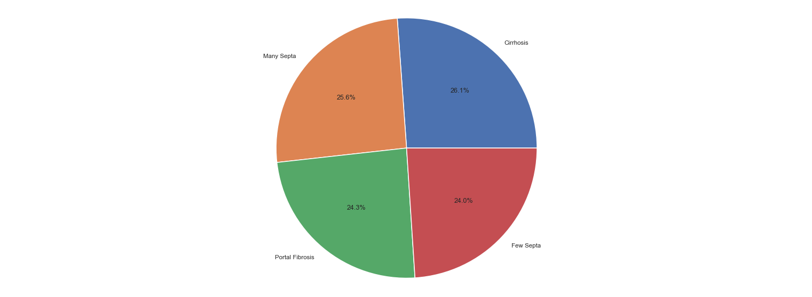

* There is no information about No fibrosis in the data set, it might help improve the model.

### ALT1

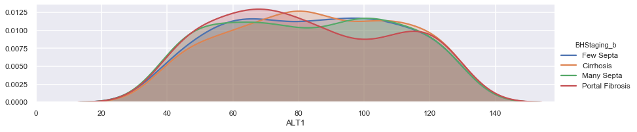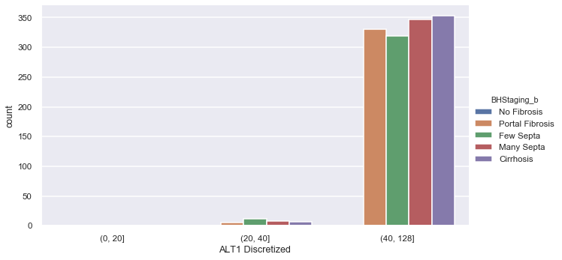

* Portal Fibrosis: ALT1 is higher around 60 to 70
* Few Septa: ALT1 range from 60 to 180
* Many Septa: ALT1 is higher from 90 to 110
* Cirrhosis: ALT1 is higher around 80
* Higher count found for Cirrhosis and Many Septa

### RNA12

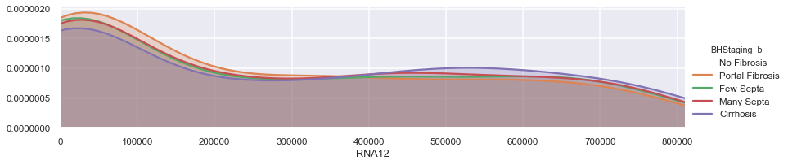 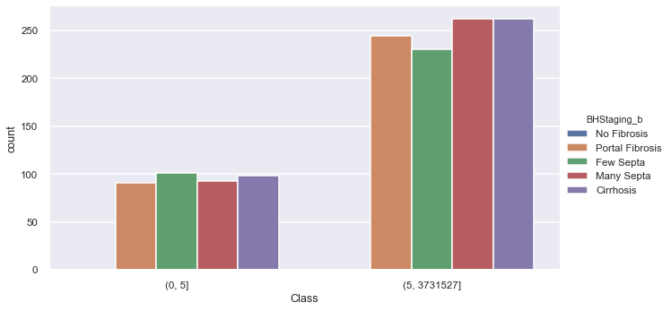

* For values less than 3000000 Cirrhosis count is less and for values higher than 3000000 count increases.
* For values less than 3000000 Portal Fibrosis count is higher, after this the count decreases.
* Many Septa and Cirrhosis has higher count for RNA from 5 to 3731527.

### ALTafter24w

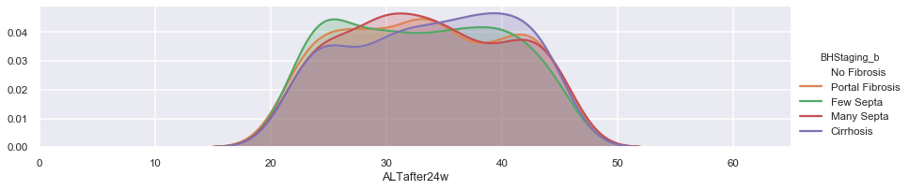 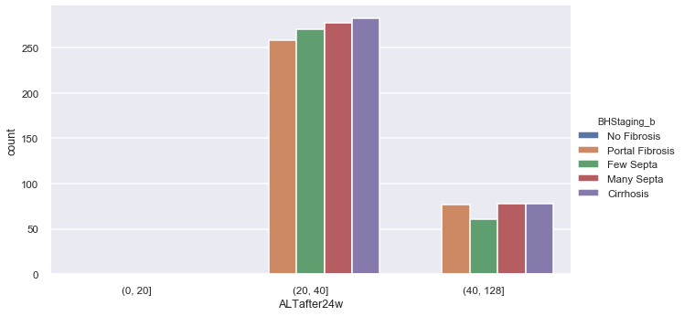

* No fibrosis has the higher count in the range of 20-40.
* Few Septa has the lower count in the range of 40-128

### RNAEF

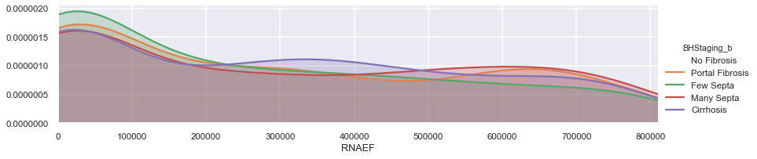 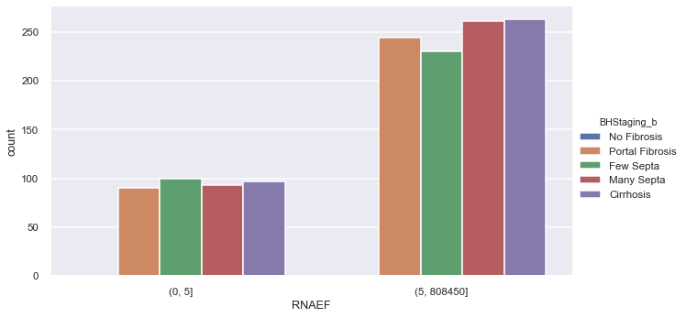

* Few Septa has a higher count on the range of 0-5

### RNABase

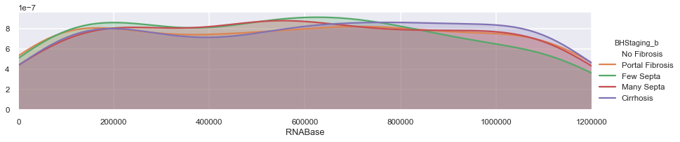 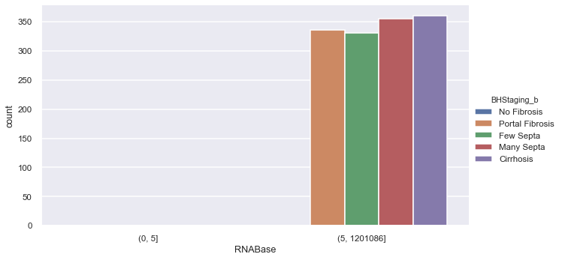

* Cirrhosis has a slightly higher count. All of the stages have around same count.

### Symptoms

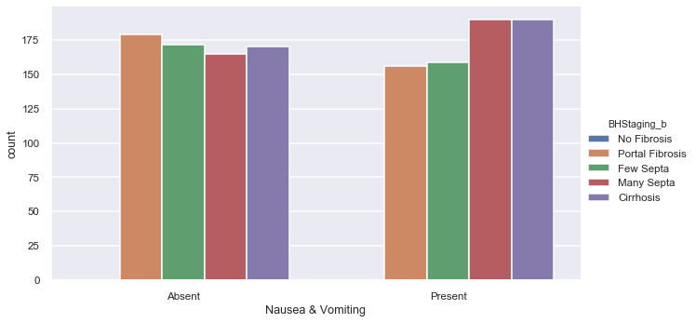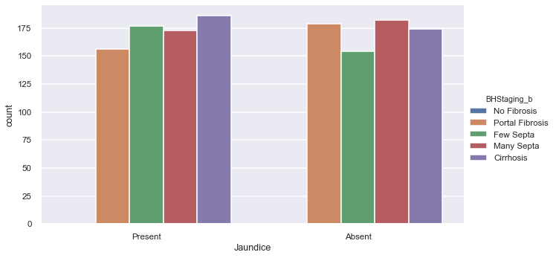

* Nausea and Vomiting has the higher correlation with BHStaging and Present count is higher for Many Septa and Cirrhosis.
* Jaundice count is higher for Cirrhosis but also a great percentage with Cirrhosis don’t have this symptom.

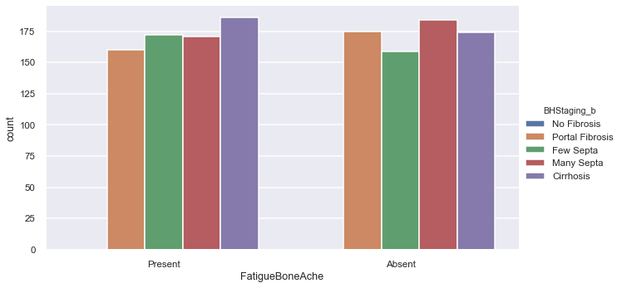

* Fatigue and bone ache count is higher for Cirrhosis but also a great percentage with Cirrhosis don’t have this symptom.
* Many Septa has the higher count with absent of fatigue and bone ache.

### WBC

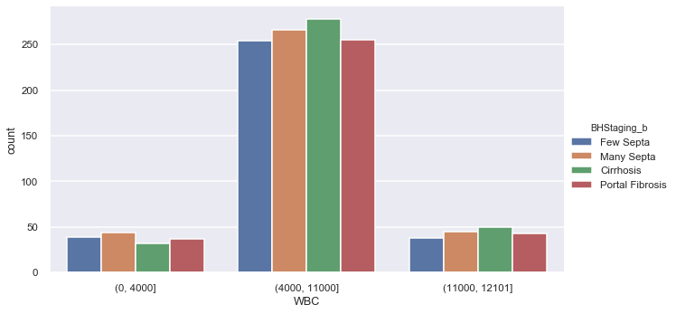

* Cirrhosis has the higher count in the range of 400-11000 and 11000 – 12101.

### Age and Gender

* 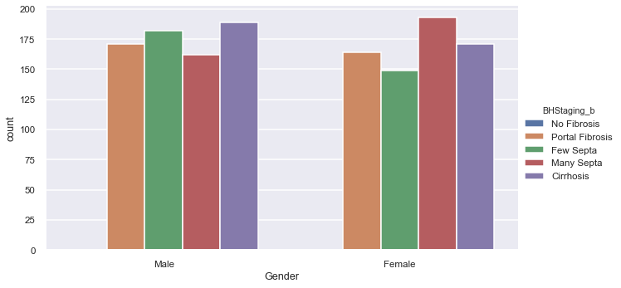There are almost the same count of Females and Males.
* Portal Fibrosis, Few Septa and Cirrhosis count is higher on Male.
* Many Septa count is higher on Females.

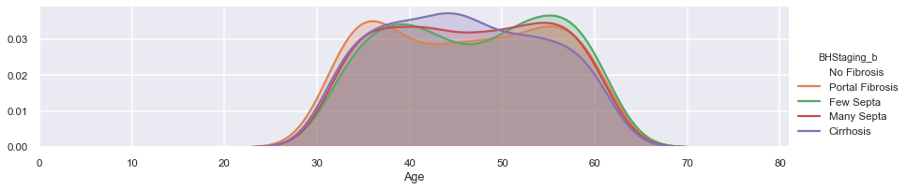

* Portal Cirrhosis count is higher on mid-thirties and mid-fifties
* Few Septa is higher on forties and mid-fifties
* Many Septa is higher on forties and mid-fifties
* Cirrhosis is higher for ages between 40 and 50

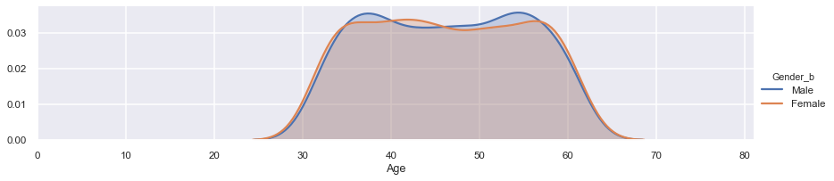

### AST1 VS ALT1/ BHStaging

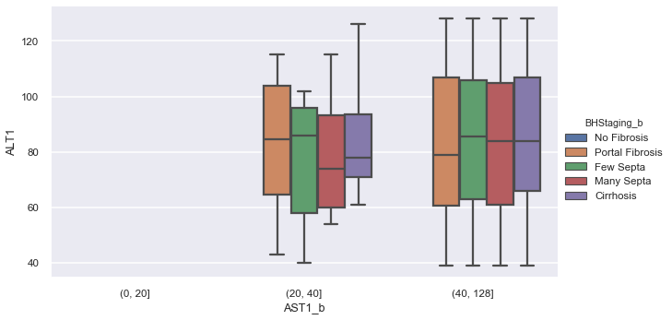

* Many septa has a lower average of ALT1 in the range of 20-40.
* Portal Fibrosis has a lower average of ALT1 in the range of 40-128
* There is no AST1 existing data for range 0-20.

### RNA12 VS RNAEF/ BHStaging

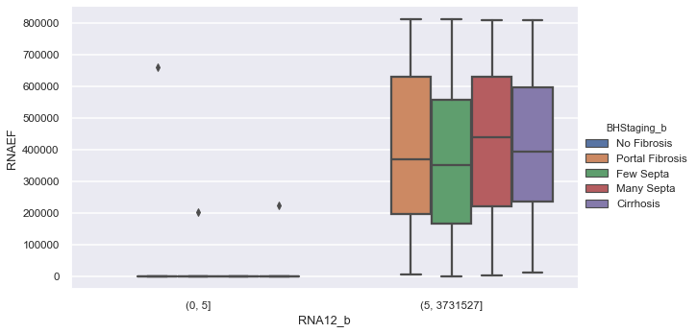

* Few Septa has a lower average of RNAEF
* Many septa has a the higher average of RNAEF
* There is no RNA12 existing data for range 0-5.

# Feature Engineering and Dimensionality Reduction

To implement feature engineering recursive feature selection with cross-validation was implemented using RandomForestClassifier.

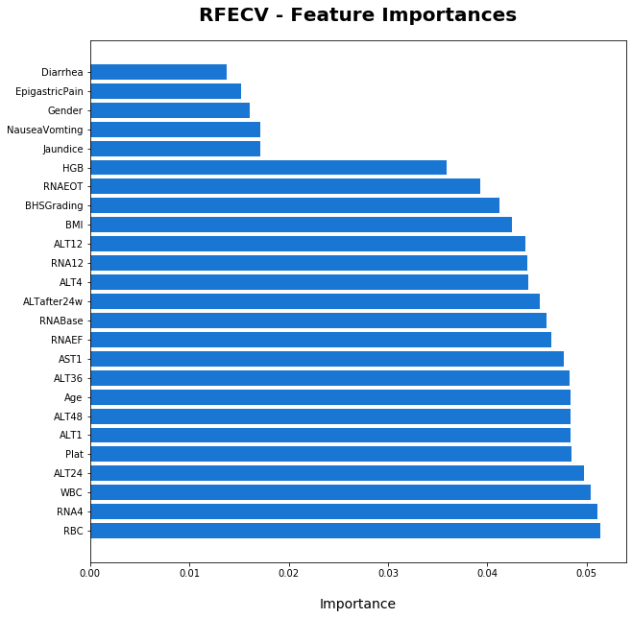

An optimal number of 25 features were found with RFE. In the graphic we can see them listed in ascending order by importance.

# One-Hot Encoding

One – Hot Encoding was implemented for the nominal features, in this case all of our attributes in the data set were discretized and hot encoded.

'Age', 'BMI', WBC', 'RBC', 'HGB', 'Plat', 'AST1', 'ALT1', 'ALT4', 'ALT12', 'ALT24', 'ALT36', 'ALT48', 'ALTafter24w', 'RNABase', 'RNA4', 'RNA12', 'RNAEOT', 'RNAEF', 'BHStaging', 'BHSGrading', 'Jaundice', 'Fever', 'Diarrhea', 'EpigastricPain', 'Headache', 'FatigueBoneAche', 'NauseaVomting', 'Gender'.

# Classification

This problem was approached with classification Techniques. Below are the classifiers implemented to build models:

* GradientBoostingClassifier
* RandomForestClassifier
* AdaBoostClassifier
* LinearDiscriminantAnalysis
* DecisionTreeClassifier
* KNeighborsClassifier

However, we were performance measure for these models was around 25% of accuracy. So, different approach has to be taken.

**Decision Rules**

Decision rules were implemented to create rules based on each one of the classifications for BHStaging:

* Portal Fibrosis
* Few Septa
* Many Septa
* Cirrhosis

To implement decision rules we used lw.RIPPER from Wittgenstein library.

**Model Tuning**

Form the selected classifiers, Random Forest Classifier was tuned using different values for n_estimators and max_depth.

Gradient Boosting Classifier was tuned using different values for n_estimators, learning_rate, subsample and max_depth.

Model Tuning was also applied to lw.RIPPER in order to obtain a better performance.

# Model Evaluation decision rules

* Four decision rules were generated to determine Staging level from these 4 rules we got a performance measure from 72% to 76%
* For Portal Fibrosis and Few Septa we obtain a precision of 0 to determine when it is positive, which means these two decision rules perfume better to determine false.
* For Many Septa we obtain a precision of .40 for true results.
* For Cirrhosis we got the higher precision of .60 for true results.

|  |  |  |  |  |
| --- | --- | --- | --- | --- |
| BHStaging | Rule | Accuracy | Classification Report | Cross Validation |
| Portal Fibrosis | [ALTafter24w_2=1^Headache_Absent=1^BMI_2=0^Gender_Female=0^Age_2=0^FatigueBoneAche_Absent=0] | 0.763689 | precision recall f1-score support   0 0.77 0.98 0.87 270  **1 0.00 0.00 0.00 77** | [0.77142857 0.74285714 0.76811594 0.75362319 0.72463768] |
| Few Septa | [Gender_Female=0^Diarrhea_Absent=1^Fever_Absent=0^Jaundice_Absent=0^Age_3=1] | 0.755043 | precision recall f1-score support   0 0.76 1.00 0.86 263  **1 0.00 0.00 0.00 84** | [0.74285714 0.77142857 0.73913043 0.71014493 0.75362319] |
| Many Septa | [Headache_Absent=1^BMI_3=1^EpigastricPain_Absent=1^Fever_Absent=0^WBC_1=1^Age_2=0^Age_5=0] | 0.720461 | precision recall f1-score support   0 0.73 0.96 0.83 253  **1 0.40 0.06 0.11 94** | [0.71428571 0.72857143 0.73913043 0.71014493 0.68115942] |
| Cirrhosis | [EpigastricPain_Absent=1^BMI_2=1^BHSGrading_12=1^Age_1=0] | 0.737752 | precision recall f1-score support   0 0.74 0.99 0.85 255  **1 0.60 0.03 0.06 92** | [0.72857143 0.67142857 0.75362319 0.72463768 0.72463768] |

# Model Evaluation for clasification

* From all three models for classification method, the one who perform better is RFE using 25 columns before discretization. Many septa had a higher precision of 0.36 compared with the rest of the staging level.

|  |  |  |  |  |
| --- | --- | --- | --- | --- |
| Technique | Model | Accuracy | Classification Report | Cross Validation |
| RFE (No discretized, 25 columns) | RandomForestClassifier | 0.285303 | precision recall f1-score support   1 0.21 0.25 0.23 77  2 0.25 0.21 0.23 84  **3 0.36 0.28 0.31 94**  4 0.32 0.39 0.35 92 | [0.25714286 0.22857143 0.30434783 0.26086957 0.26086957] |
| ohe(discretized) | LinearDiscriminantAnalysis | 0.270893 | precision recall f1-score support   1 0.27 0.22 0.24 77  2 0.22 0.24 0.23 84  3 0.30 0.31 0.30 94  4 0.29 0.30 0.30 92 | [0.18571429 0.2 0.33333333 0.33333333 0.23188406] |
| Raw (no discretized) | AdaBoostClassifier | 0.270893 | precision recall f1-score support   1 0.27 0.26 0.26 77  2 0.24 0.24 0.24 84  3 0.29 0.27 0.28 94  4 0.28 0.32 0.30 92 | [0.31428571 0.1 0.14492754 0.26086957 0.31884058] |

**Recommendations:**

* Include “No fibrosis” Staging data
* Discretization for RNA Base, RNA 4, RNA EOT, RNA EF is [0; 5], ]5; 1201086], contemplate dividing on more than two bins.
* Need to investigate and compare other techniques and algorithms of Decision Rules to improve performance.